<https://www.juvander.fi/site/Home/Blog/tabid/128/EntryId/170/Exporting-and-Importing-data-from-QC-using-Import-Export-Utility.aspx>

**Exporting and Importing data from QC using Import Export Utility**

Jun 16

Written by: Ilpo Juvander   
6/16/2011 2:47 PM  [RssIcon](https://www.juvander.fi/site/Home/Blog/tabid/128/rssid/3/Default.aspx)

To show how Import Export Utility is used to export test cases with design steps from Quality Center follow this procedure.

Import Export Utility for Quality Center can be downloaded from [here](https://www.juvander.fi/site/Downloads.aspx).

From startup screen select first Connect QC:

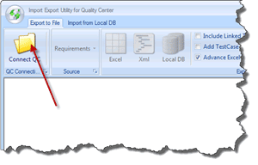

Fill in server url, login name and password and then Domain & Project:

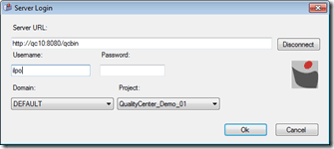

Then switch to Test Cases selection mode. You can also export requirements, test sets and components from Quality Center using this tool. This shows test plan tree in the selection area:

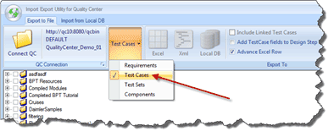

Next step is to pick test cases to export from Quality Center. This can be done either by individual test case or by folders:

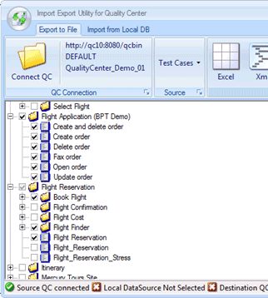

At this point it is possible select three different export targets:

1. Excel, data is exported into Excel format
2. Xml, data is exported into xml format
3. Local DB, this uses Import Export utility internal format which is used to transfer data from one project to another

By selection Excel, you will just pick a location, file name and in Save as type Excel version (2003/2007/2010).

For Excel and Xml, you will pick needed fields, for Local DB option all fields are exported.

To pick which fields you want to include in your export:

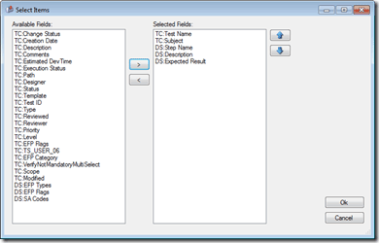

You can also reorder fields in this dialog. TC stands for Test Case, DS is Design Step.

By selecting Ok it start the export process and for Excel and xml export target types you will be asked to open this or not:

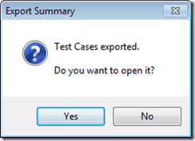

For Local DB option it is possible to import data from sdf file back to Quality Center.

From main screen switch to Import from Local DB:

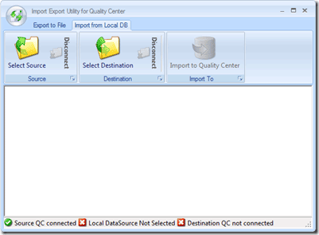

First click Select Source to pick your previously created sdf file and from that file select project:

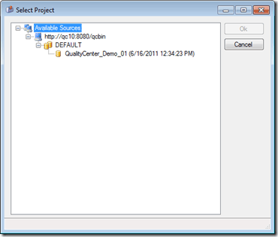

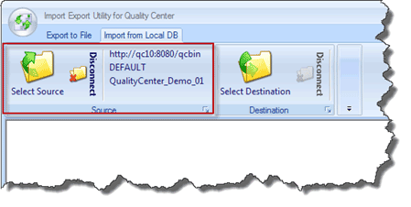

Then click Select Destination as your QC server, domain and project.

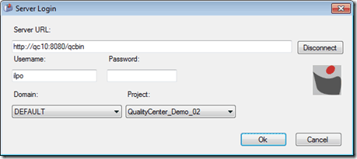

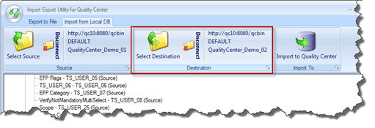

At this point you have possibility to Ignore fields my right mouse clicking selected field;

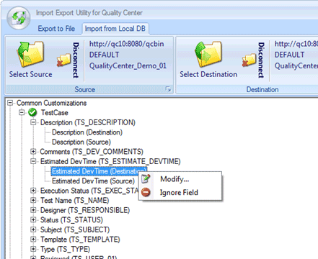

Or modify with what field this is mapped to in Destination Project:

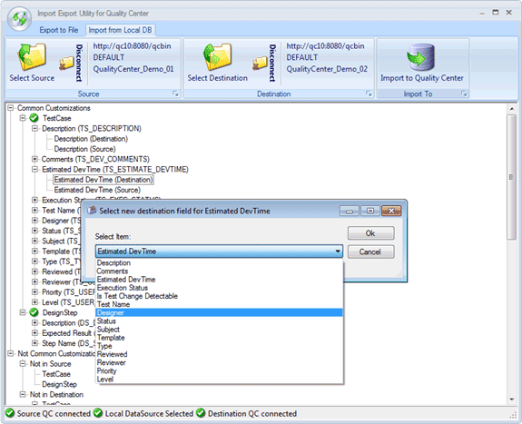

You can also see which fields are Not in Destination by scrolling down:

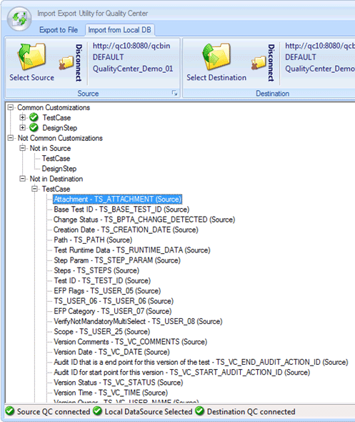

Same modify and ignore fields are available here as well. Note that not all of the fields are modifiable through this tool so some of those are listed in here as well.

Once all fields are ok and verified, select Import to Quality Center:

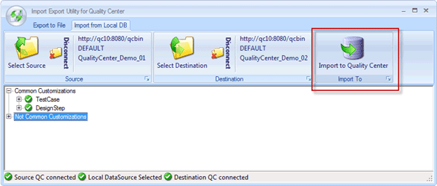

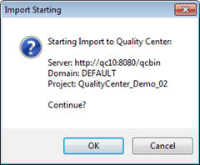

For large amount of data this will take some time, depending on your server and network connection speed.

After this you should login into your destination project and verify that all data is there.

Note that it is not recommended to view destination project structures while import is ongoing as this might put locks which do not allow updates to that test case.